The pn Junction

General Point - Fermi Level
A key point to bear in mind from the first part of this course is that the in any piece of material that is under no applied field, the Fermi Level must be at the same energy at all points. Thus if we have two materials and we join them there may be a redistribution of charges to allow the this to occur. This redistribution can result in an internal field in the device (or a built in potential)
The built in potential does not cause a flow as the probability of finding an electron with a particular energy is the same on each side.
For example if we place two pieces of Metal together where the Fermi Level is different then there will be a flow of the electrons from the material with the higher level to lower level. There will also be an interfacial charge between the layers too, however the high carrier densities in a metal mean that we can ignore it.

p-n junction and Fermi Level
In the p-n junction we have bring p- and n-type pieces of semiconductor together:

On bringing the two materials together there is clearly an higher density of free electrons on one side of the junction and a higher density of holes on the other. The electrons and holes will diffuse across the jucntion due to the concentration gradient for filled and empty states in each of the conduction and valence bands. Furthermore on diffusing across the junction they can recombine with the majority carriers there. The diffusion of these free electrons and holes will lead to exposure of the ionised donor and acceptor atoms. This leads to an Electric field across the junction, and, as 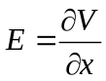, to a built in potential. This built in potential builds up until such a point as the field is sufficient to oppose the diffusion of carriers across the junction. At this point the Fermi level will be flat across the whole device.

Note as the Fermi Level is flat the conduction and valence bands on each side have been shifted with respect to each other. The barrier height at the junction is equal to eV₀.
We can obtain the barrier height from considering the number of electrons on each side of the junction:
In the n-region: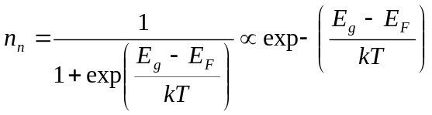
In the p region 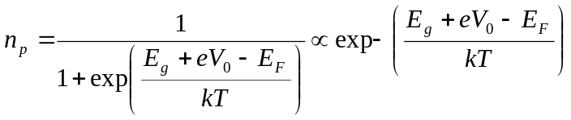
Combining the above: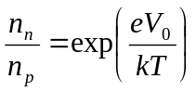 and hence 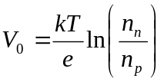
If 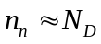and 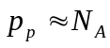 and sustituting also for 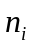: 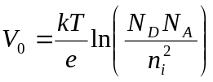

p-n junction: applying Forward Bias
In forward bias the barrier is reduced by an amount equal to eV, where V is the applied voltage. This can be represented in our diagram as a splitting of the Fermi Level in to two parts at the junction:

The lower barrier, given by e(V₀-V) leads to carriers being able to flow from the contacts and recombine the the junction region. High current can flow.
The two split parts of the Fermi Level are known as Quasi Fermi Levels.

p-n junction: applying Reverse Bias
In reverse bias the barrier height is increased to e(V₀+V) where V is the applied voltage. Once again we can represent this in our band diagram by a splitting in the Fermi level at the junction. As the barrier is increase we get no majority current flow, but can have a small leakage current from electrons in the p-type material diffusing into the junction and vice-versa for the holes.

Diode Equation
Considering the equation above we had:
which van be rewritten as 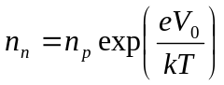
Applying a forward bias, V gives: 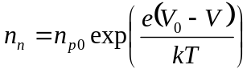
Where 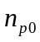 is the value of the electron density on the p-side of the depletion region. This will be increased due to the diffusion of carriers across the junction. Now Let
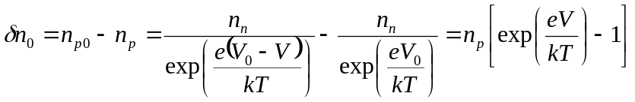
We can similarly obtain a relationship for 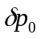
In the junction electrons diffusing into the p-material will recombine when they meet up with a majority carrier hole. The higher the density of holes the shorter the lifetime of the free electron in the p-material will be.
It can be shown that the minority carrier recombination is given by: 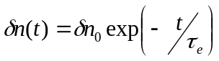 where the characteristic minority carrier lifetime,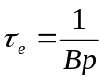 (where B is a constant)
Similarly during the time the electrons are in the p-material they can diffuse away from the junction travelling a certain distance into the material before recombining: 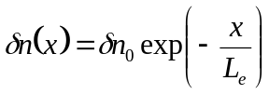 where the characteristic minority carrier diffusion length 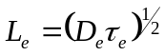 where D_{e} is the diffusion coefficient.
Returning to our diode, under a particular forward bias there will be a certain total number of electrons in the p-side of the junction (with electrons recombining with holes and further electrons diffusing into the p-material.
The total charge can be given by 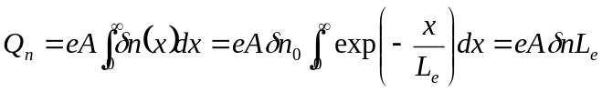
Current is charge /time so the total current flowing through a diode will equal the charge recombining on the p- and n- sides of the junction per unit time. This can be given by the total charge on each side divided by the respective minority carrier lifetimes:
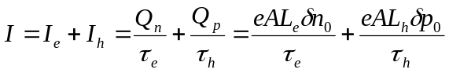
And substituting we get 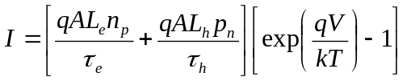
This is the diode equation:
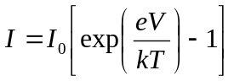, where is the saturation current 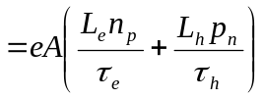
This is an ideal equation for the Diode. Note that it works in forward and reverse bias.
We will consider the equation in Forward Bias for Emitters.

Ideality Factor
In the above we have considered the situation where electrons and holes diffuse across the junction and recombine. In this case the current is controlled purely by the minority carriers.
However, there is also the situation where electrons and holes recombine in the junction itself in this situation the current rise is dependent both on the density of electrons and holes. It can be shown that the diode equation becomes
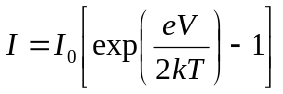
The general form of the equation is 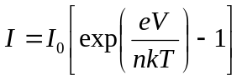 where n is the “ideality factor” which typically lies between one and two. In materials with high defect densities other effects, such as defect related tunnelling can dominate giving very high ideality factors (n>2). This is a not an atypical problem in widebandgap visible LEDs for example.

Series Resistance

While the ideal diode equation can tell us about the behaviour of a semiconductor junction, ultimately the exponential rise will be limited by resistive effects:
1
2
3
4
At the currents where a light emitting diode or laser diode typically operate these will form a significant fraction of the voltage drop of the diode, and the current will rise linearly with applied voltage This can be described in forward bias by:
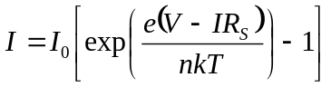
where R_{S} is the series resistance term.

